CLARIFY password resets

These are the types of tickets we get for Clarify users for password resets.

This is my login ticket, but we can also get an AOTS ticket which is recommended, and also Q message.

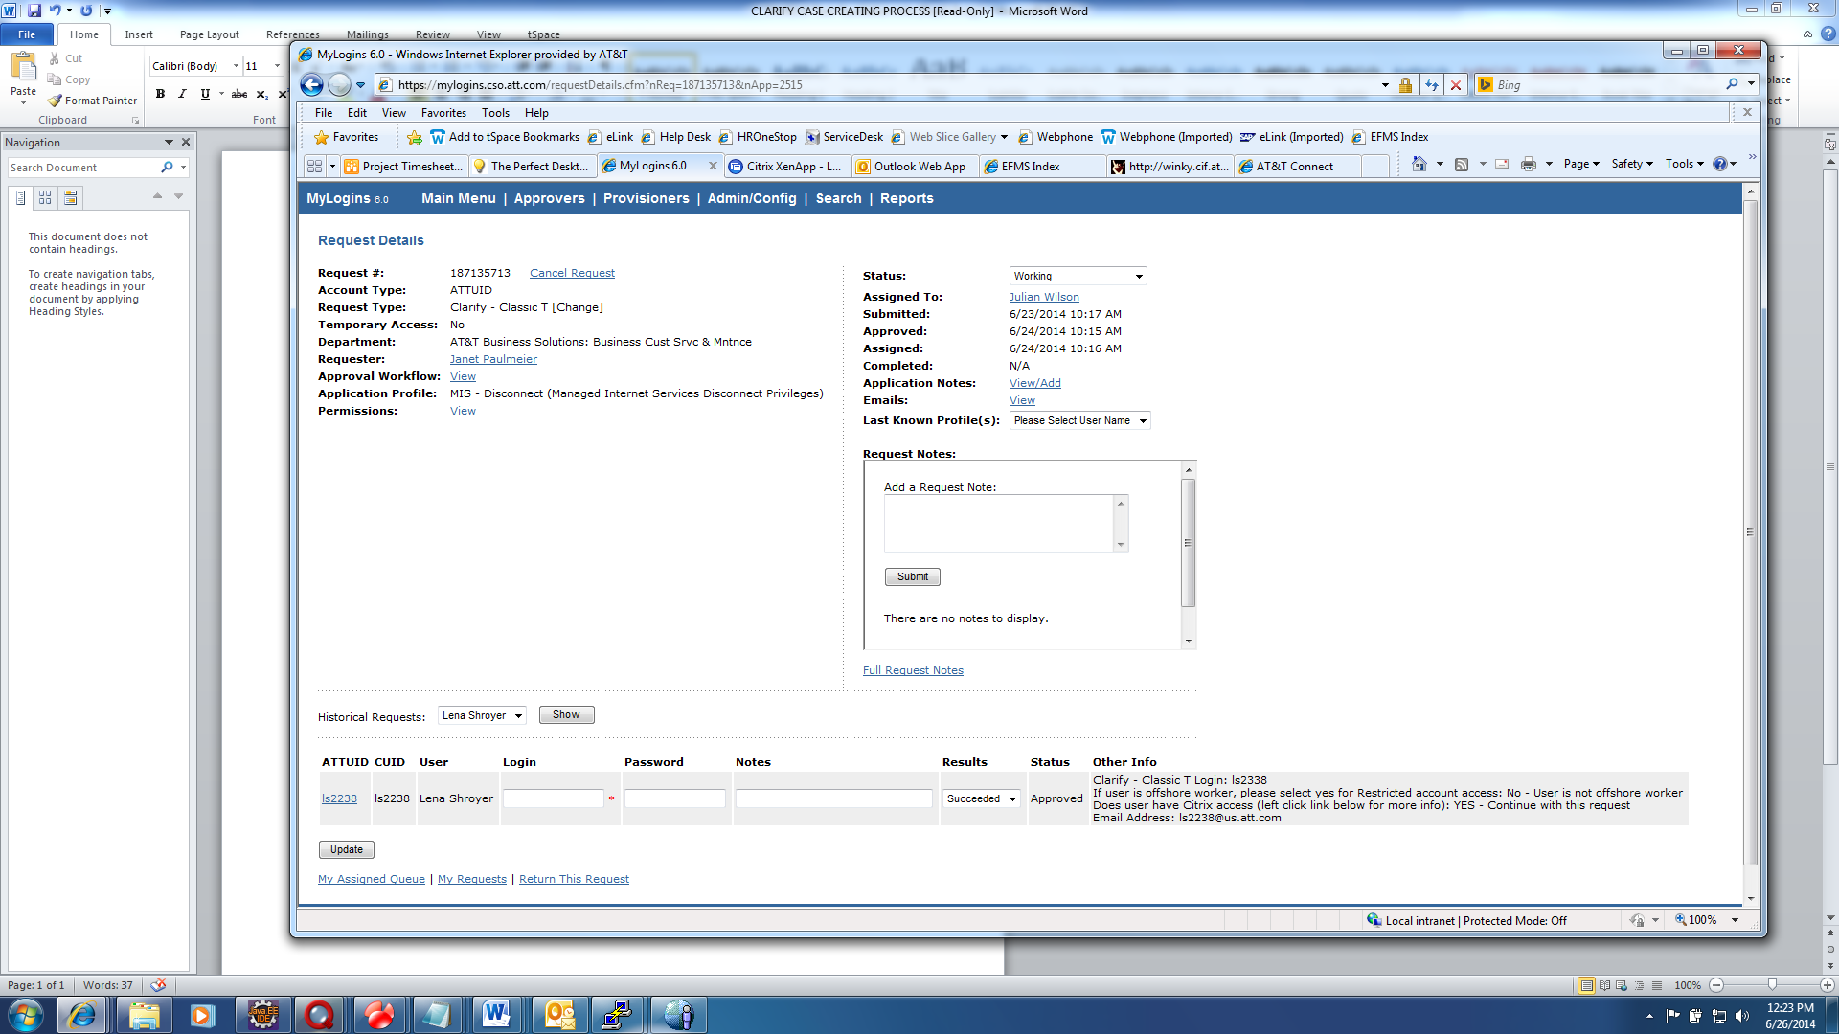

Next we go to clarify and get the user’s last name to make sure the user has a clarify ID and also sometimes the user just puts their ATTUID which isn’t the full clarify ID to use.

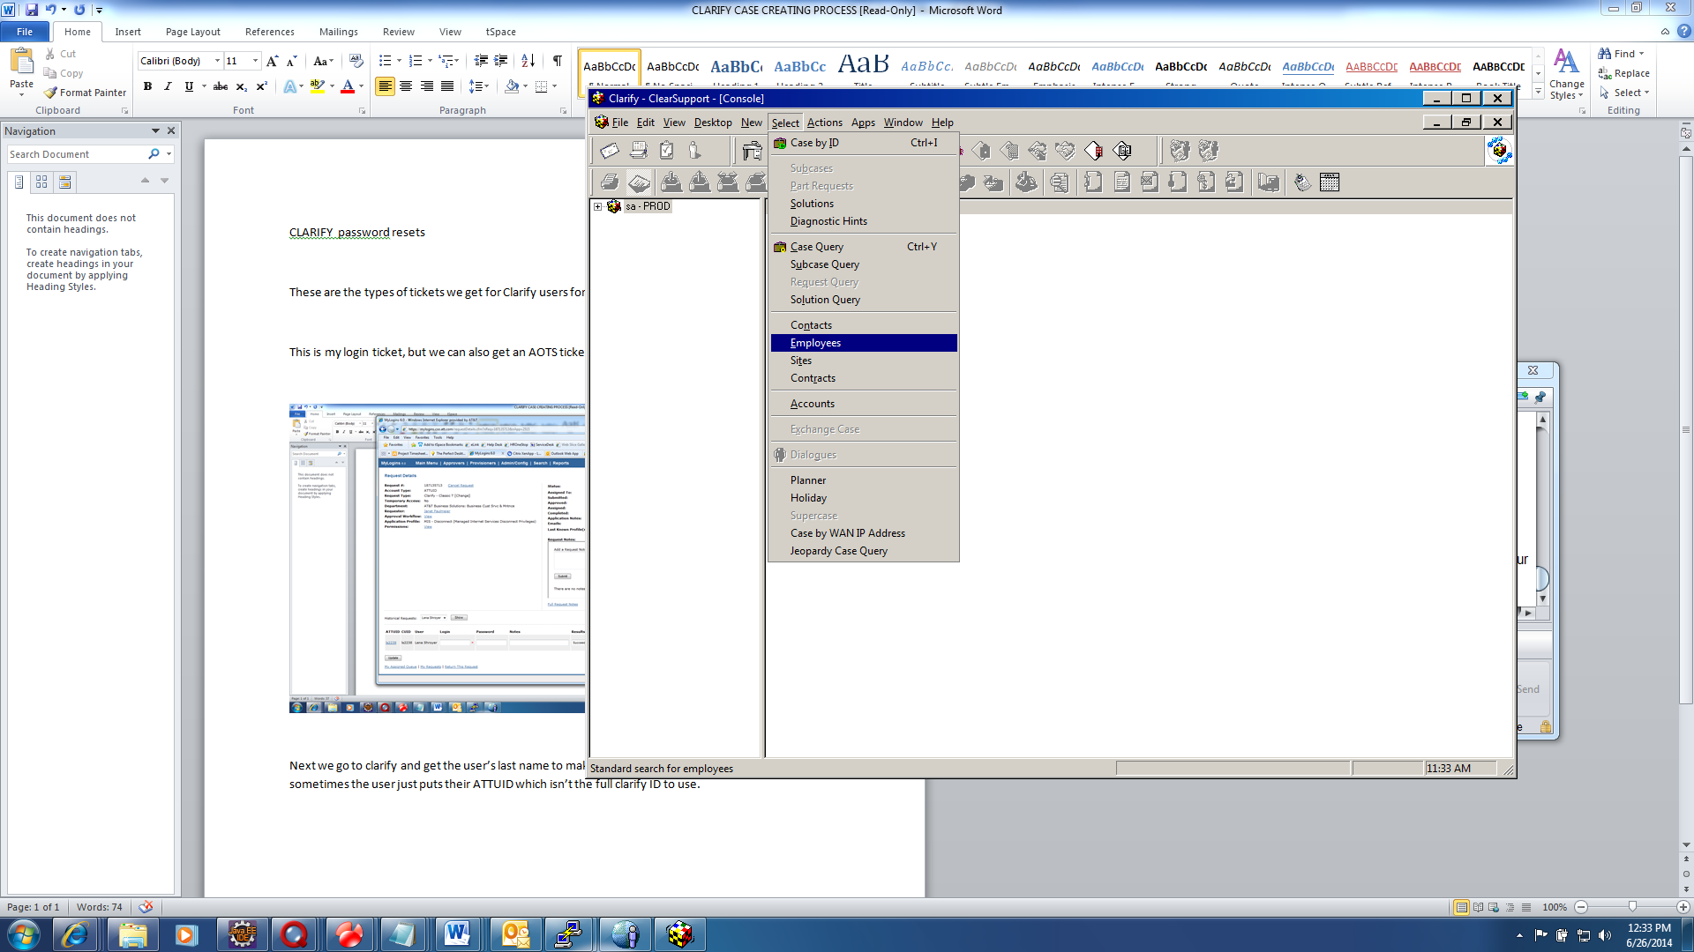

Then type users last name in the field and click list:

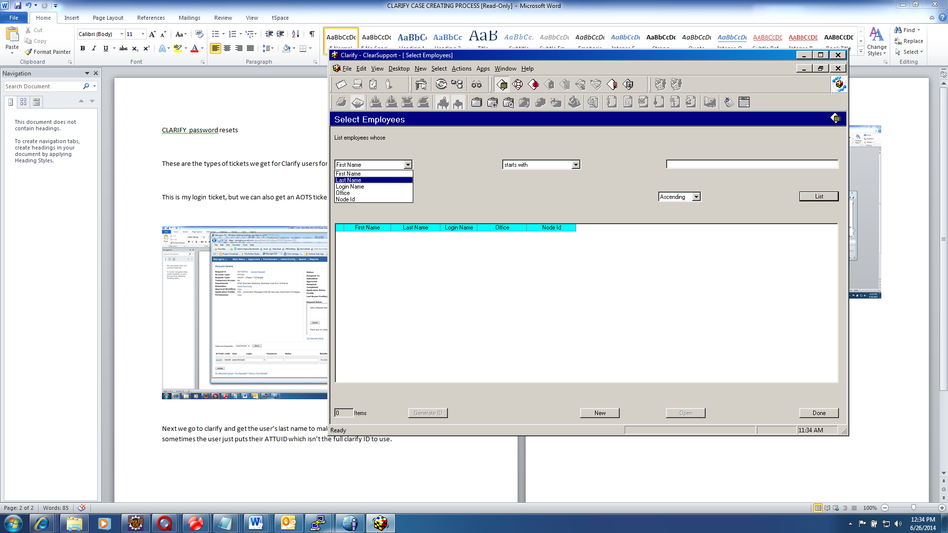

The user is listed here and has their online privilege set and their user name etc. The 6 (in yellow) fields that need to be populated are there.

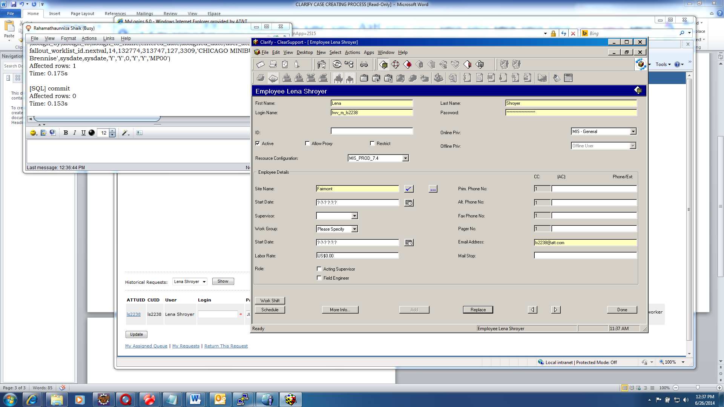

Now we login to the database and manually reset the system date in clarify. We copy the login name from clarify and change the sql script and put that name in place of the name that is there.

update table_user

set last_login = sysdate, passwd_chg = sysdate

where table_user.LOGIN_NAME = 'fwv_m_ls2238'

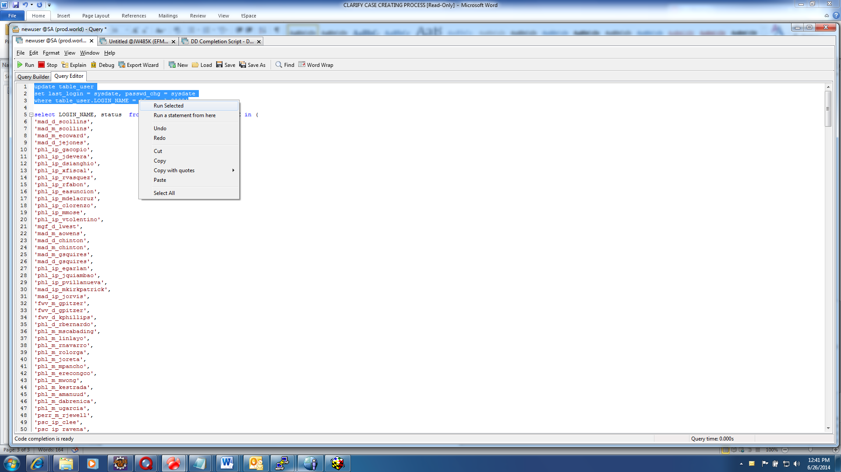

Now we run the script and it succeeded..

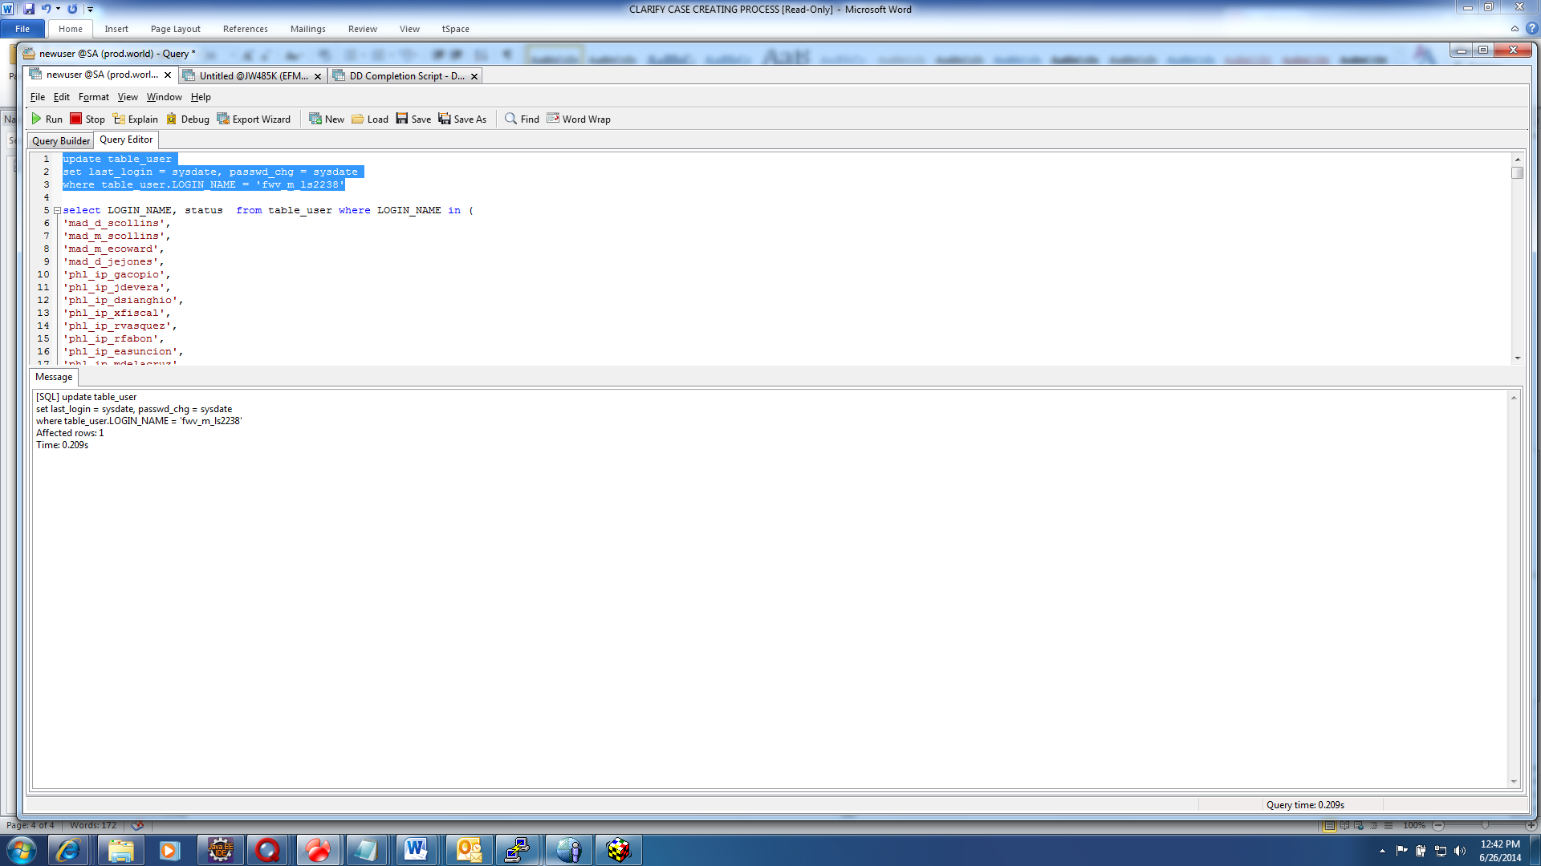

Now we go back to clarify and we choose the rest password option to reset the users password.

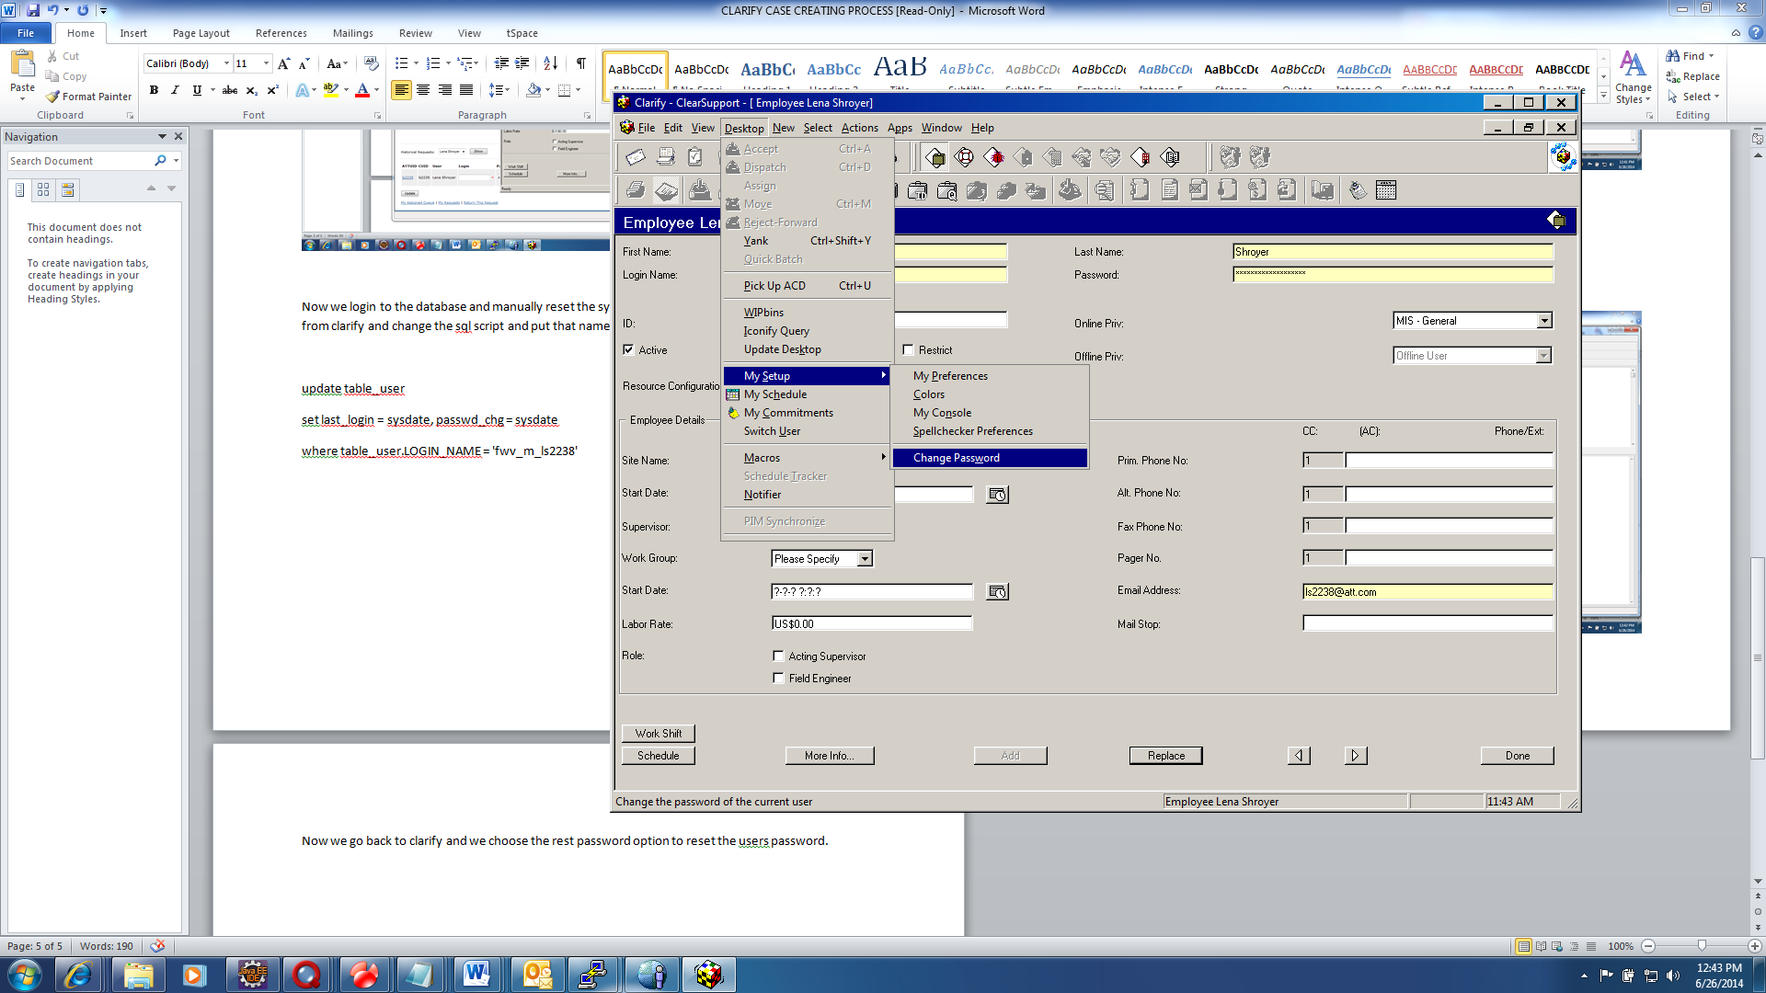

Then we get a popup dialogue box and we add their name to the login name and set their password to the month (in all CAPS) (two special chars and Numeric values) (ex. JUN##123)

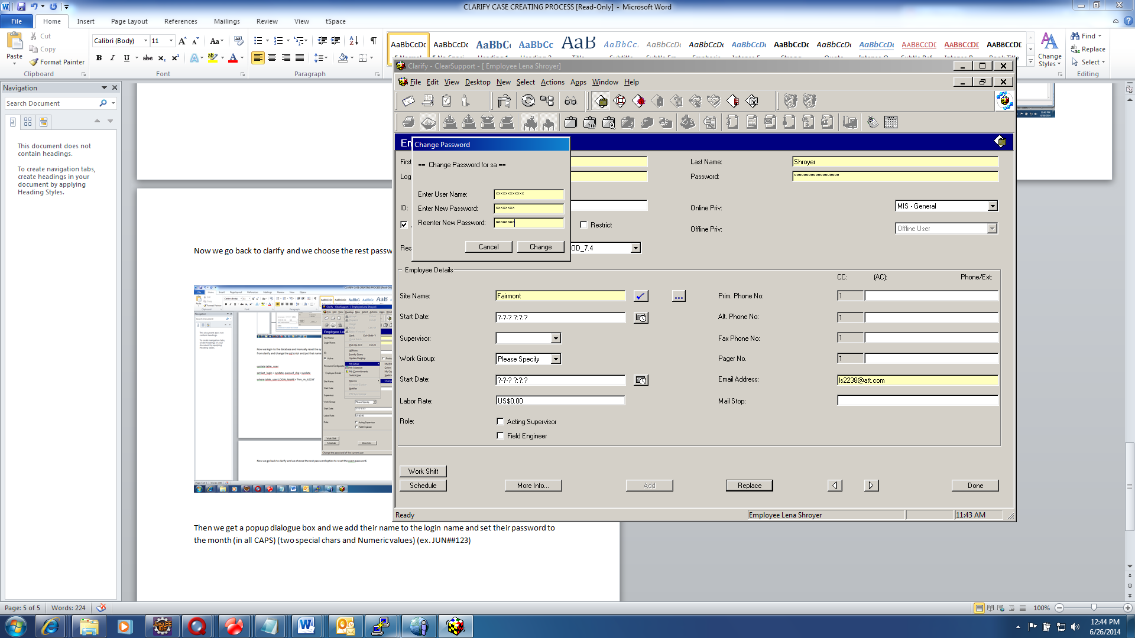

That’s it. All is done.

CLARIFY USER CREATION

Next my logins ticket is the same type of ticket.

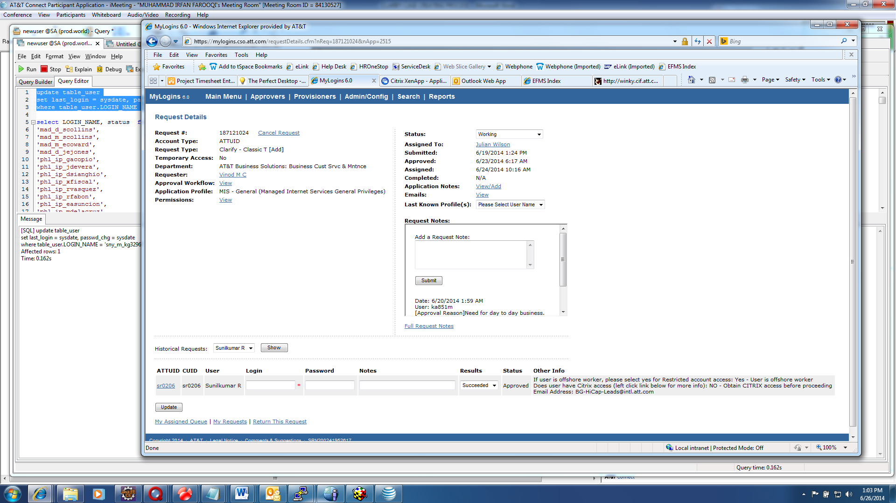

Next we go to clarify and choose employees and new:

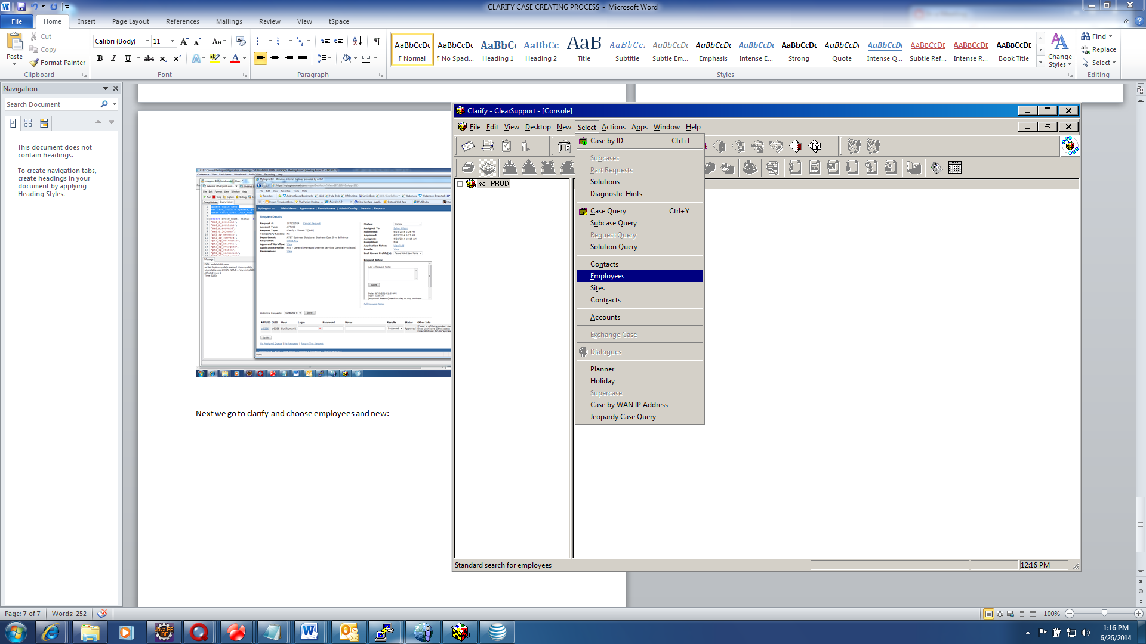



Next we have to choose which online priv and resource configuration for the user.

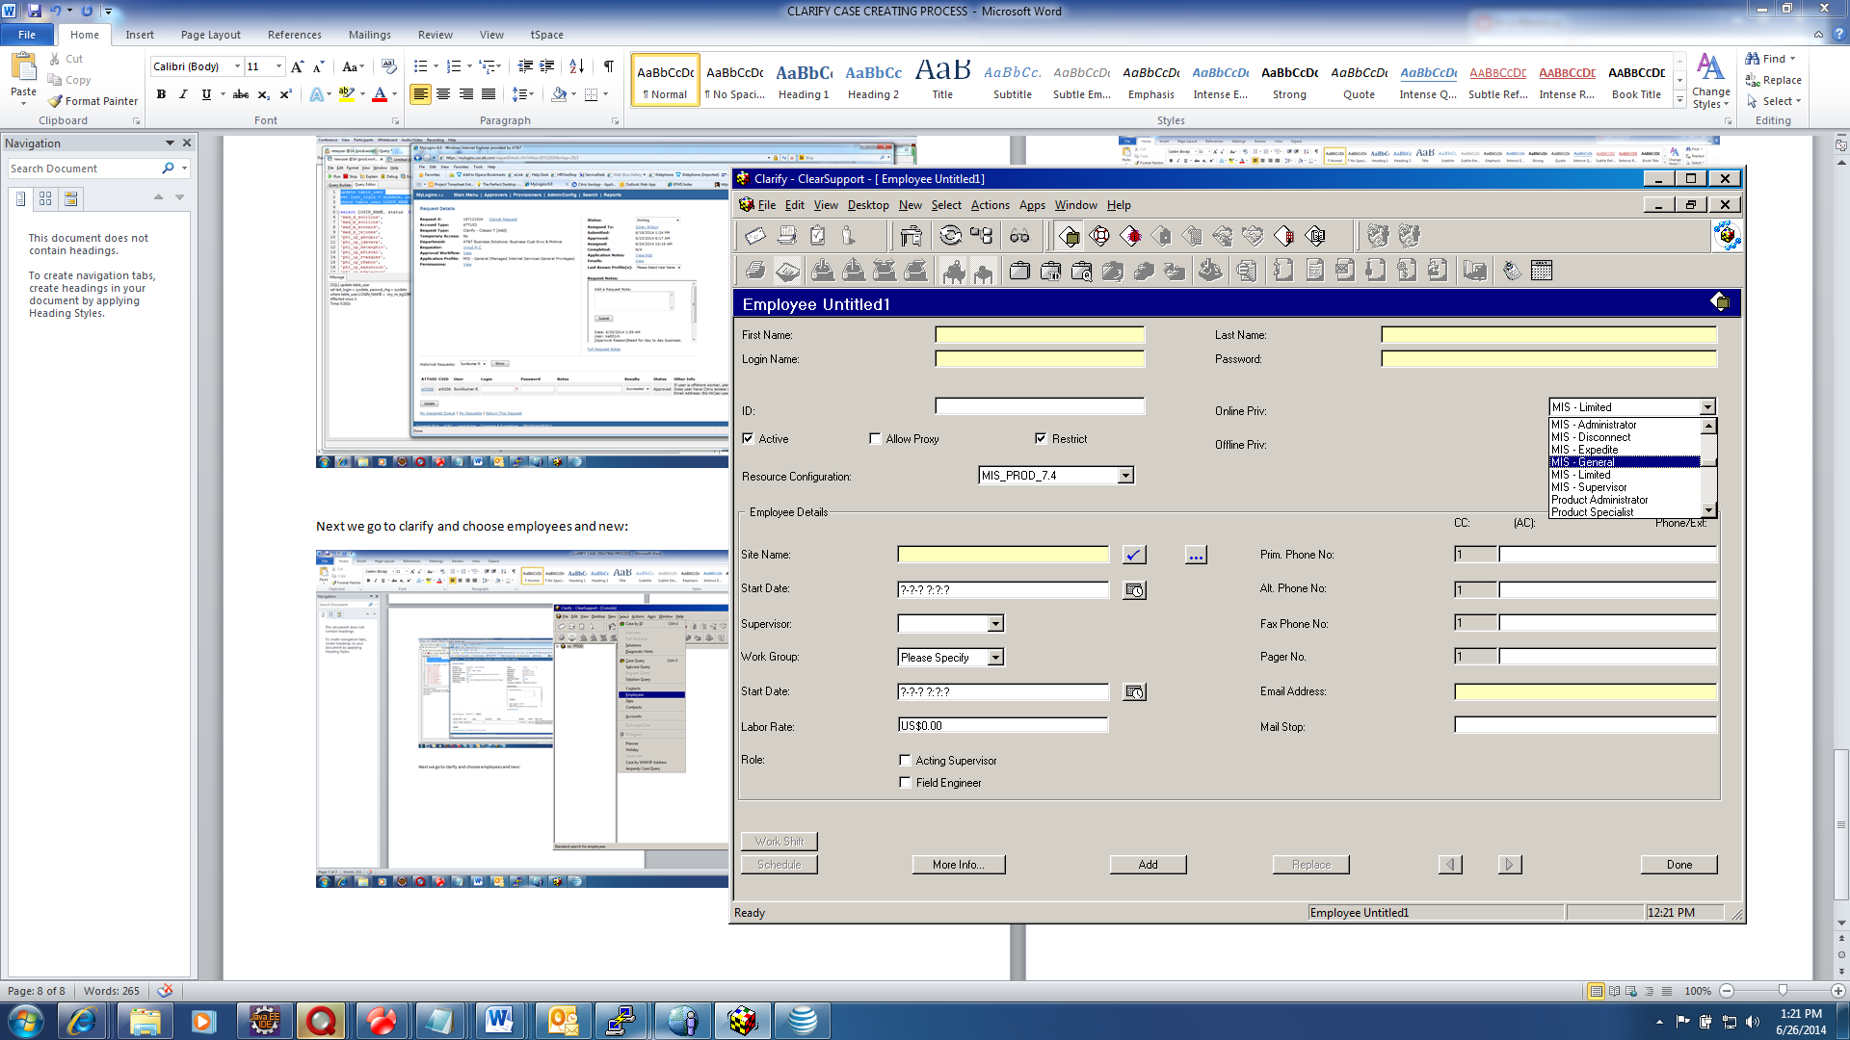

The 6 fields in yellow is where we input all the information along with online priv and resource configuration.

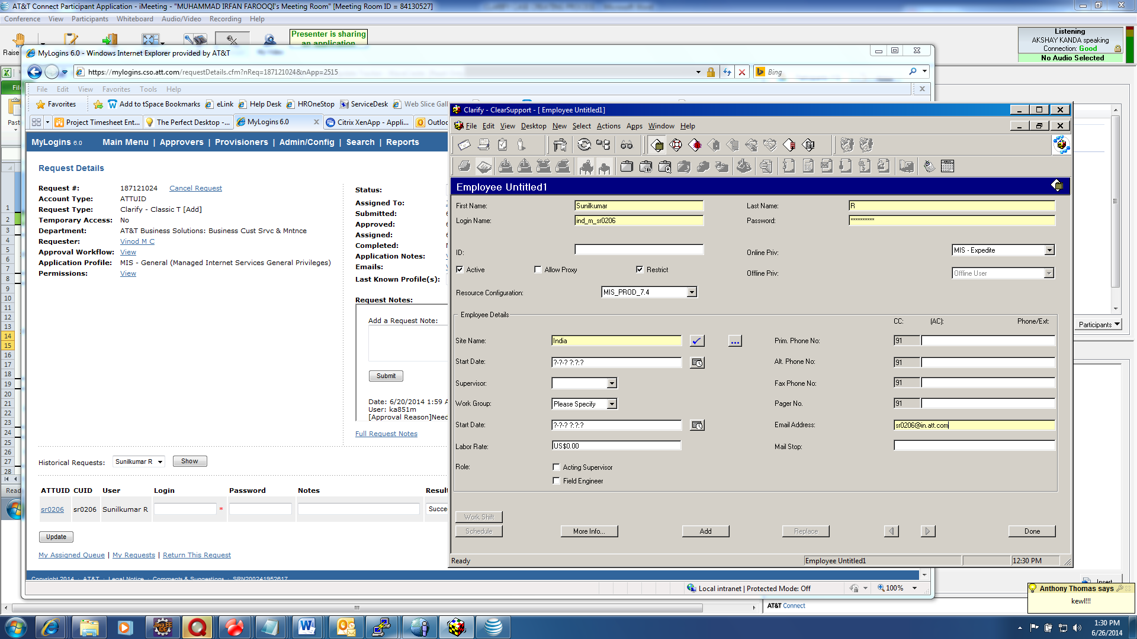

Note the 6 fields that need to be populated.

Then we hit add in clarify.

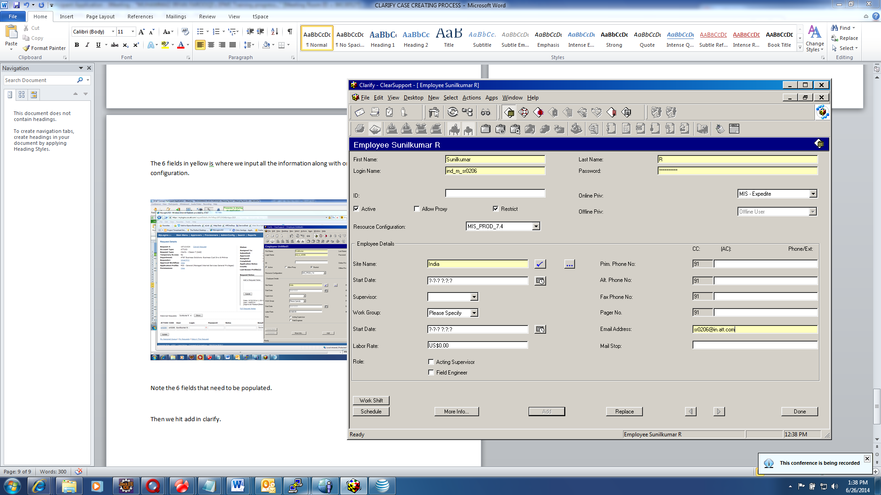

Then we have to reset the password even for a new user: So we copy the login name in clarify..

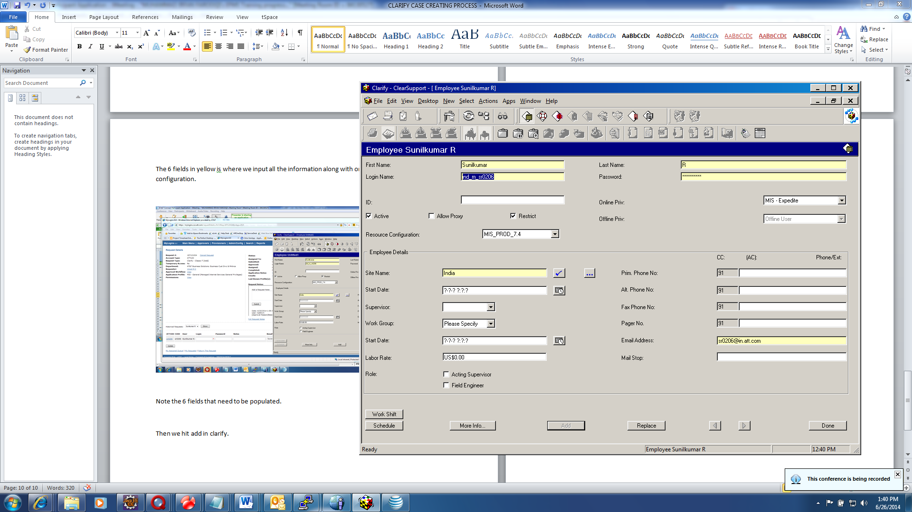

Then we go to Navicat and the new user script. We change the username to the user we want to reset.

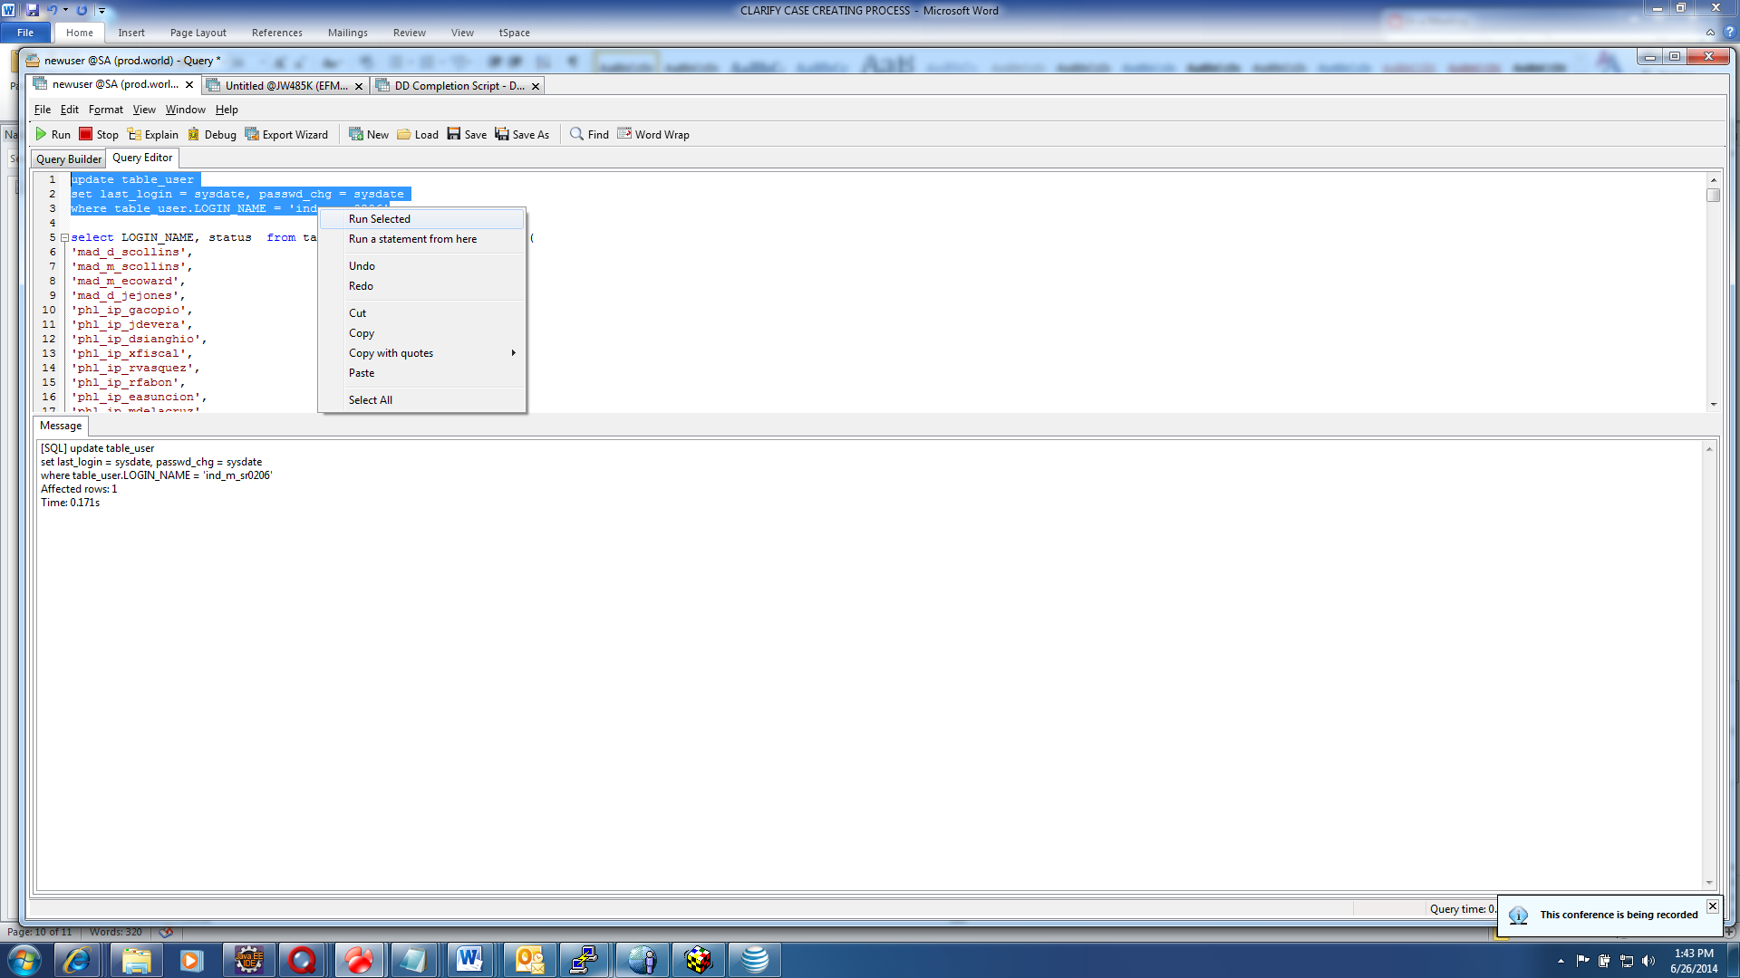

And run the script.

Then we go back to clarify and click desktop and change password

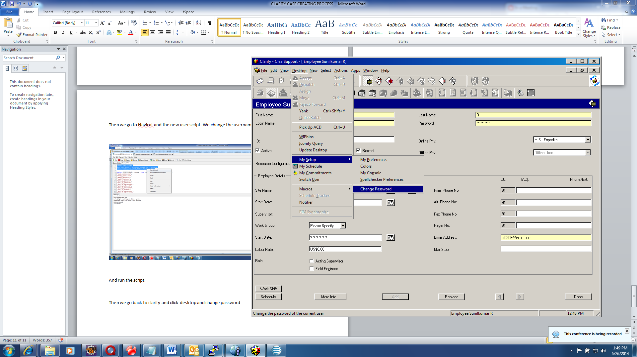

The password prompt will pop up and we need to add the user name and new password in pop up box.

